Papers written by Australian Maths Software

SEMESTER TWO

REVISION 1
MATHEMATICS METHODS
UNITS 3-4

2016

SOLUTIONS

SECTION ONE
1. (8 marks)
✓

(a) 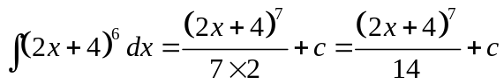
✓

(b) 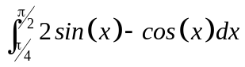
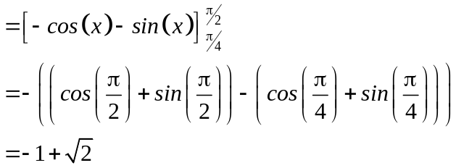
✓

✓

✓

✓

(c) 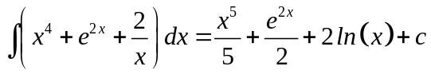
✓✓ -1/error

2. (16 marks)
(a) (i) 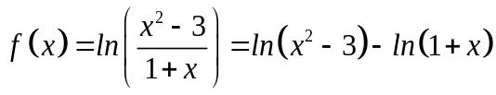
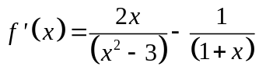
✓

✓

(ii) 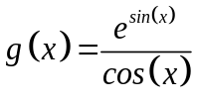
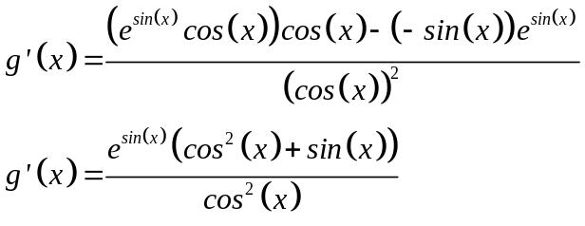
✓

✓

✓

(iii) 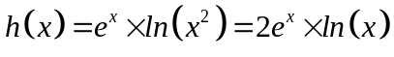
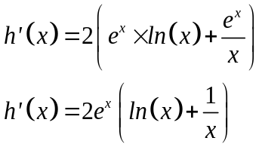
✓✓

(b) (i) Given 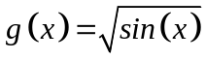 show that 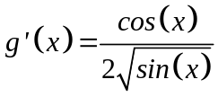.
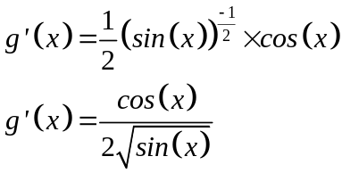
✓

✓

✓

(ii) 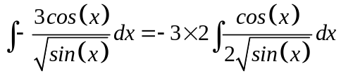
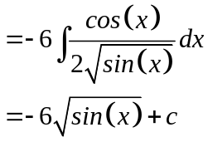
✓

(c) 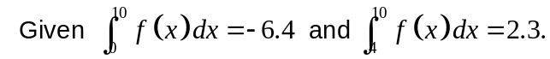
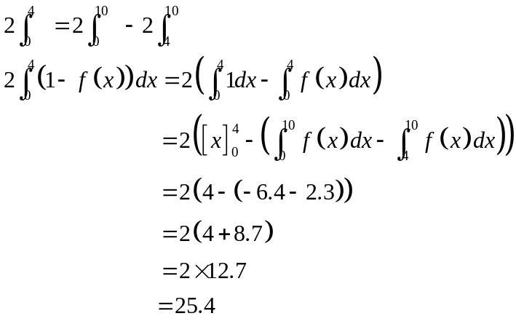
✓

✓

(d) 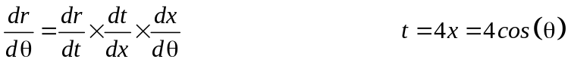
✓

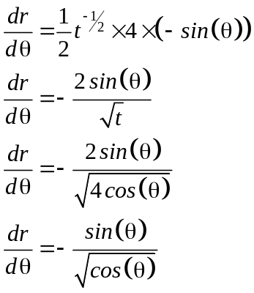
✓

✓

3. (6 marks)
(a) 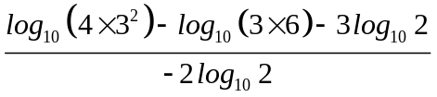
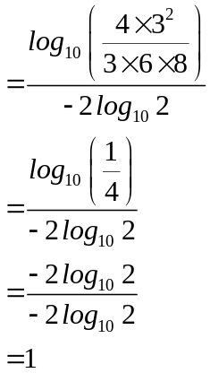
✓

✓

✓

(b) 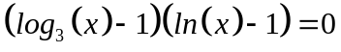
✓

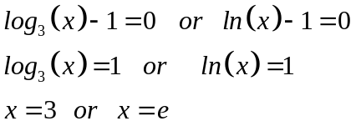
✓

✓

4. (6 marks)
(a) (i)
✓✓

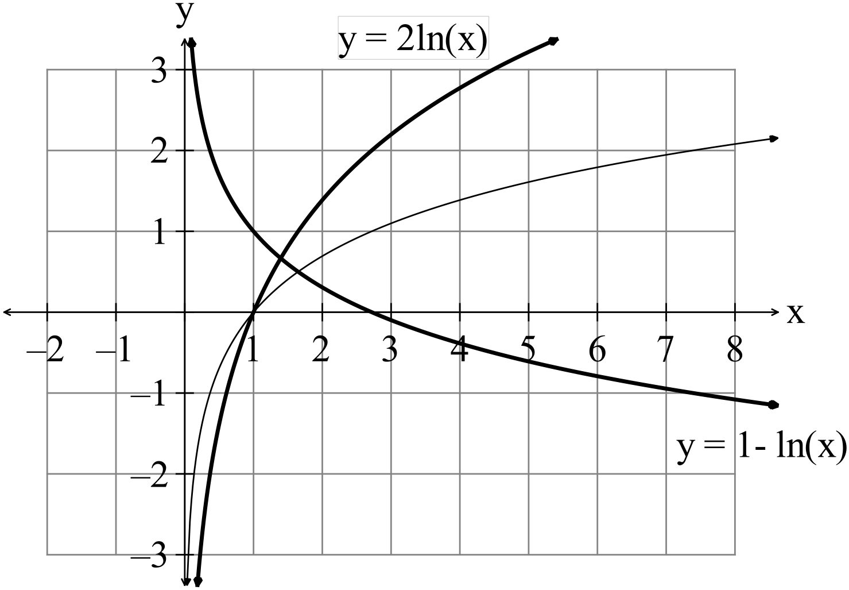
✓✓

(ii)
✓

✓

5. (16 marks)

(a) (i) Not a probability density functions as you cannot have negative probabilities.
✓

✓

✓

(ii) Is a probability density functions as the probabilities add to one.

(b) The shape will be a tightly clustered histogram, close to a normal curve.
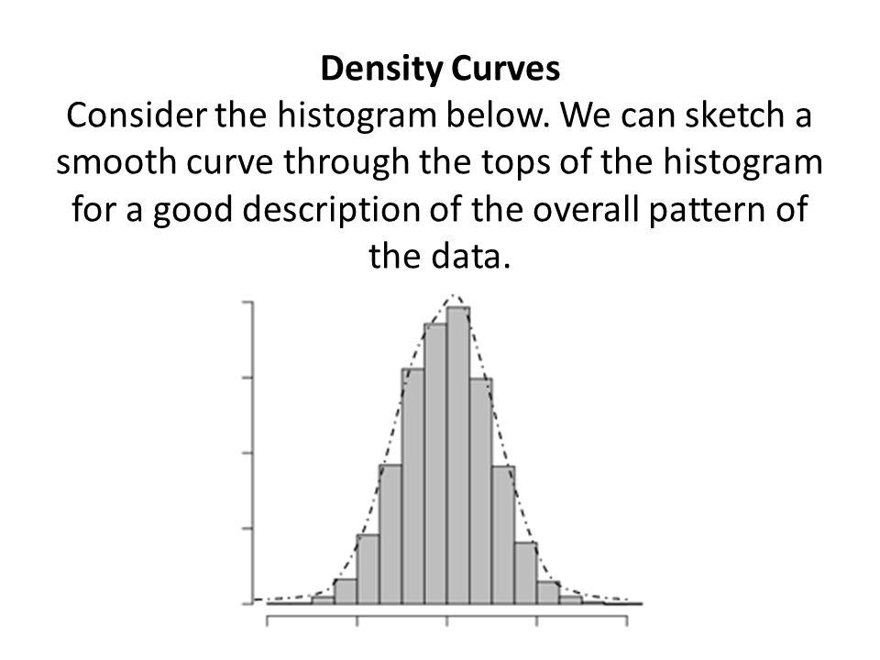
15
✓✓

(c) (i) 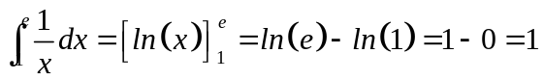
✓

✓

✓

(ii) 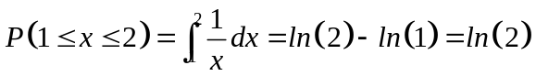
✓

✓

(d) 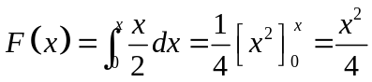
✓

✓

(e) 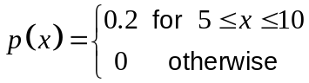
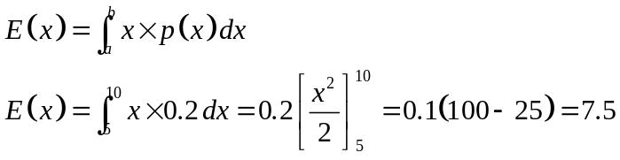
✓

✓

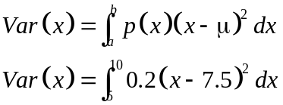
✓✓

END OF SECTION ONE

SECTION TWO
6. (7 marks)
(a) 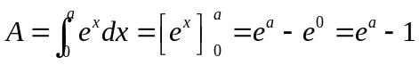
✓
✓
✓

(b) 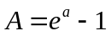
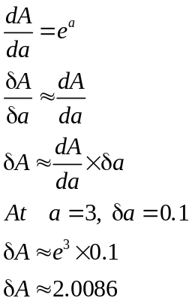
✓
✓
✓
✓

7. (6 marks)
(a) 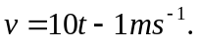
✓
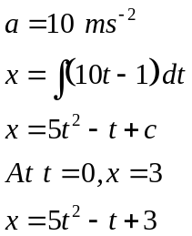
✓
✓
✓
(b) Changes direction when 0 i.e. at t = 0.1

(c) 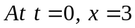
✓
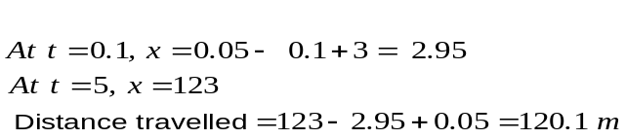
✓

8. (7 marks)
(a) (i) 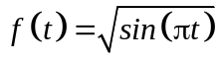
✓
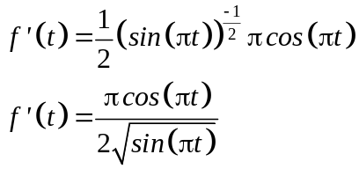
✓
✓

(ii) 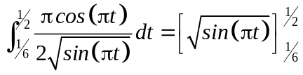
✓
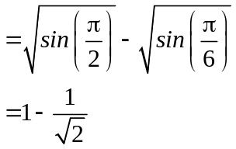
✓

(b) 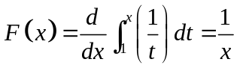
✓
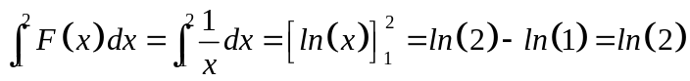
✓

9. (8 marks)

(a) Turning points occur when 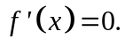
✓
✓
There are no points where this occurs so there are no turning points.
✓
Likewise, there are no points where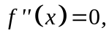 so there are no points of inflection.

(b) 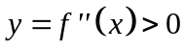 which suggests that the concavity is concave upwards for all x values.
✓✓

(c) 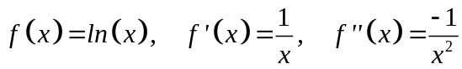
✓
✓
✓

10. (7 marks)
✓✓
(a) 0.693 ( = ln(2))
✓
(b) (i) True as +C can have any value
✓
(ii) No, this is bounded and has only one solution.
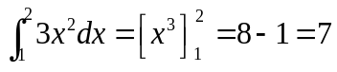
✓
(iii) True.

(iv) 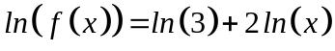
Not valid as initially, x can be negative as it is squared.
Need 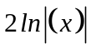
✓✓

11. (8 marks)
(a) 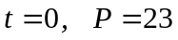
✓
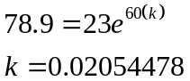
✓
✓
(b) 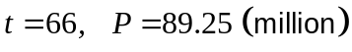

(c) Te actual population is smaller than 89.25 so the growth rate is slowing down
✓
✓
(minimally!)

(d) 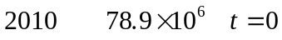
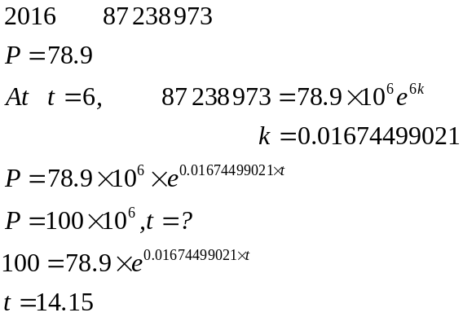
✓
✓
✓
The population is expected to reach 100 million just into 2025.
12. (7 marks)
(a) 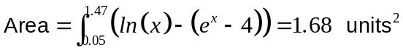
✓
✓
✓
(b) (i) 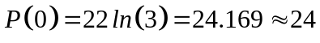
✓
✓
(ii) 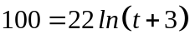
✓
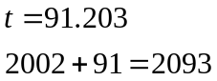
✓
The population will reach 100 in 2094 or just into 2094.

13. (7 marks)
(a) 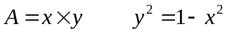
✓
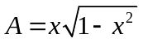
✓

(b) Maximum area when 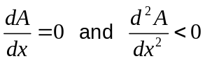
✓

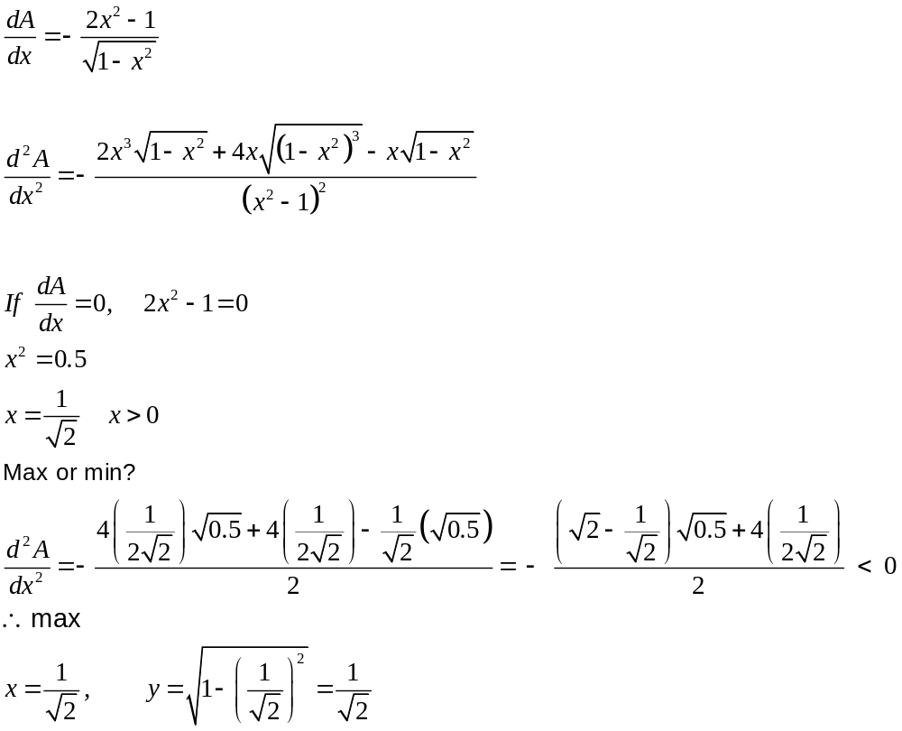
✓

✓

✓

Therefore 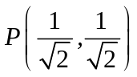
✓

14. (6 marks)
(a) (i)
✓✓

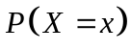 | 0 | 1 | 2 | 3 | 4 | 5 | > 6
 | 0.1465 | 0.366 | 0.3945 | 0.068 | 0.015 | 0.0075 | 0.0025

(ii) 0.366+0.3945 = 0.7605
✓ ✓
(iii) 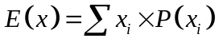
✓

✓

15. (7 marks)
(a) P(a given battery will last at least 400 hours)
✓ ✓

(b) P(a given battery will last between 320 and 380 hours) 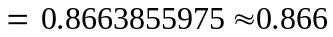
✓ ✓

(c) P(Jenny’s battery will run out in a 3 hour exam if it has been used for 340 hours ) 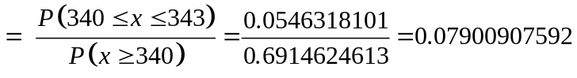
✓
✓
Therefore P(Jenny’s battery will run out in a 3 hour exam if it has been used for 340 hours already) 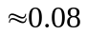
✓
16. (6 marks)
(a) P(there are 5 girls and 5 boys) = 0.24609375
✓ ✓

(b) P(there are no more than 4 boys) = 0.376953125
✓ ✓

(c) BB(8 more births) Binomial with n = 8
✓
P(exactly 4 girls) = 0.2734375
✓
17. (22 marks)
(a) (i) A biased sample is one in which not every sample point has equal chance of
✓ ✓

being selected.

(ii) A sample that is chosen in such a way that each point has an equal chance of
being selected. The process requires each possible selection point being
numbered and then the sample is generated using random numbers.
✓ ✓

(iii) A skewed distribution is a set of data where a large proportion of the data is
clustered at one end.
✓ ✓

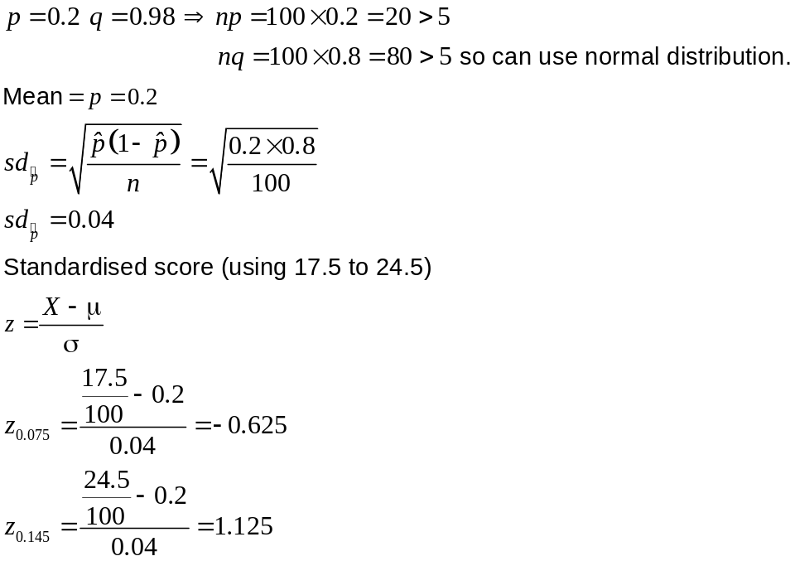
(b)
✓
✓
✓
✓
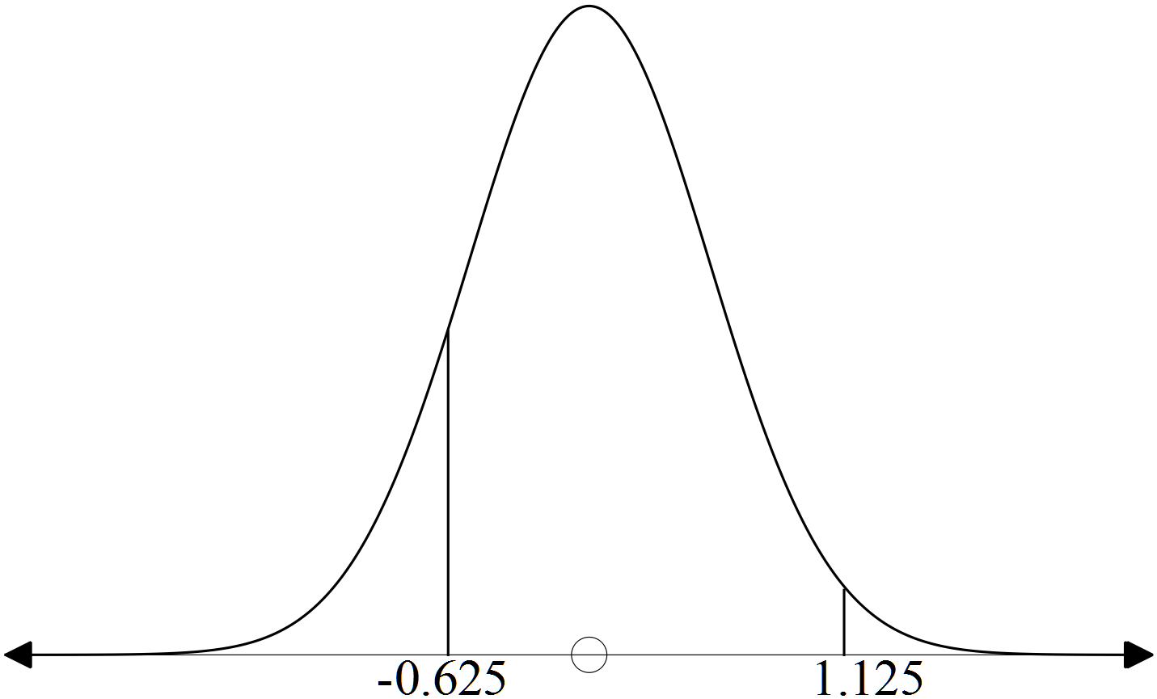

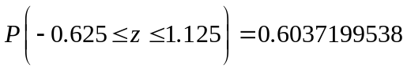
✓
✓
The probability that between 18 and 24 of the wine tasters should not drive is 0.604.

(c) (i) 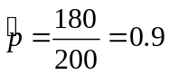
✓

(ii) 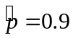
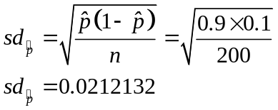
✓
✓

(iii) 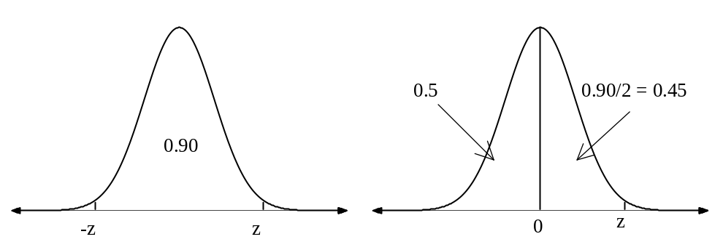
P(X< z) = 0.95
✓
✓
z = 1.645
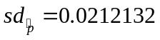
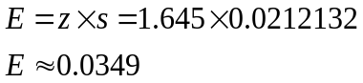
✓
✓
✓
The 90% confidence limit are 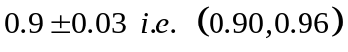
(d)
P(X< z) = 0.95
✓
✓
z = 1.645
✓
Use 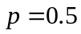 as the maximum value as is unknown.
✓
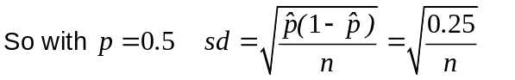
E = z × s but 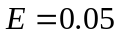

Therefore
✓
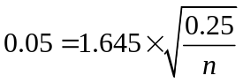
✓
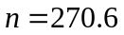

You need to survey 271 people to have an error margin of 5% at a
confidence level of 90%

END OF SECTION TWO

